{ourney Steps

W:n”ch *tep of the experience are you de*cr:'b !ng 2



W:nat d oes the

cu*to •ne • do ! W:nat informaiion do they looñfo * What is their conrext?

Discovery

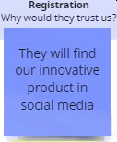Why do they even start thejourney?



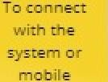They search for good child safety gadget in social media



Why would they irnztre others?



Needs and Pa ins

What doesthe customs want @ .

to ach eve or avoid ?

7io. *Redme omnigui ,* eg. zy

us.'ng rñe rs• oersorz n orrotor. children

# 1.Aware

Rechuce be crime happened to the children by tracking the

child‘s location in

google map

## T.Social

To.hamea

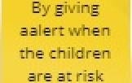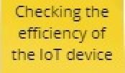

devtre



May not kno*w* howto use the gadget

1.Live



Ok dhé• zgert messages

de tee

cléf4nen lheszmny



Tou ch point

W:nat part oftheservice da t ney intera ct v/”th !

What is the custome fee ing* 7ip. Use */-e etnoji opp to axoress moreemo•.'one

ore«rtuna ..



WhatcouId'x.e”moroveo•

inc•oduce !

# the people 2.Social media



Interested,hesitant

-Inform and educate

-Chart solution to problem

media/Ads 2.Website 3.Blogs



1.Phone call 2.Email enquiry

envi ronmenc 2.Knowledge base

3.5 upporc



Collect feedback actively

PNT2022TMID12698

Increase/decrease a leading metric by comparing costs

Considered the location and price.



Refer the

friends in social media afterthefirst

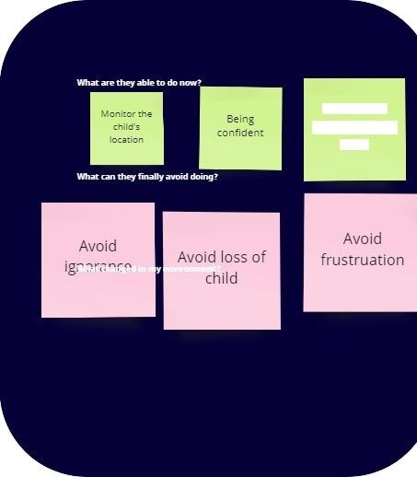

Ensurethe

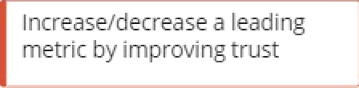

Increase/decrease a leading metric by improvingtrust

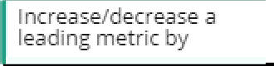

I ncrease/decrease a leading metric by